File ↕  Rank ↔ |  |  | 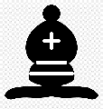 | 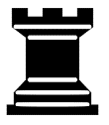
Starting Position  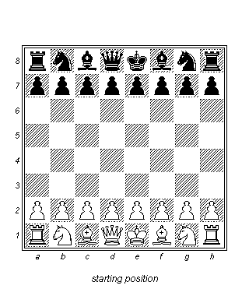  - Files run up and down  - Ranks run side to side  - White on ranks 1 & 2  - Black on ranks 7 & 8  - Each square has a coordinate: a1, c4, h8  - Use ranks and files to advance your game  - Use ranks to develop your pieces  - Use files to get them into position  - White starts game | Moving the PAWN  - Think of your Pawns as a marching army, moving in formation up the board  - Pawns don’t retreat; they move 1 square, forward only  - A Pawn may move 1 or 2 squares when first moved  - Pawns capture diagonally | Special PAWN Moves  Pawn Promotion  When a Pawn reaches the other side of the board, it becomes a stronger piece: Bishop, Knight, Rook or, most commonly, a Queen.  En Passant  If your opponent moves a pawn two squares, in an  attempt to pass the square where your pawn would be able to take it, and arrives alongside your pawn, you may take the pawn as if they had moved it only one square, only on your next turn. | Moving the BISHOP  - Bishops move diagonally, forwards or backwards  - Bishops always stay on their starting color: one moves along light squares, the other moves along dark squares | Moving the ROOK  - Rooks move in straight lines, either side to side or up and down the board  - Rooks, like the Bishop and Queen, may move as many squares as desired or permitted; if they bump into or capture another piece they must stop | Moving the KNIGHT  - Knights move in the shape of the letter “L”  - Either up 2 and over 1 or up 1 and over 2  - The Knight is the only piece that can jump over other pieces | Moving the QUEEN  - Queens move in straight lines, like Rooks, and diagonally, like Bishops  - The Queen is your most powerful piece, yet not all powerful, for instance, she cannot move like a Knight | Moving the KING  - The King moves in any direction, only one square at a time  - You cannot move your King into danger, or check  - You never capture, or remove the King from the board  - Kings cannot be next to each other
 | 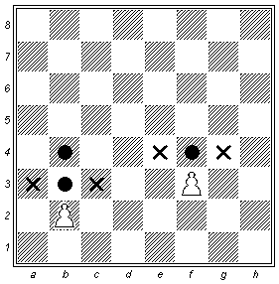 |  | 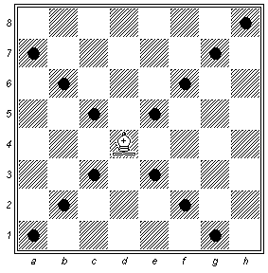 | 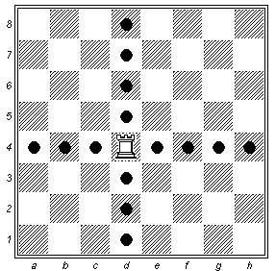 | 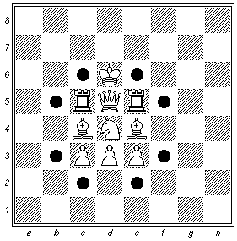 | 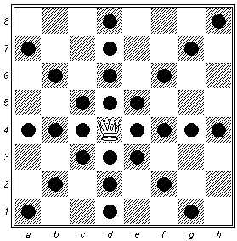 | 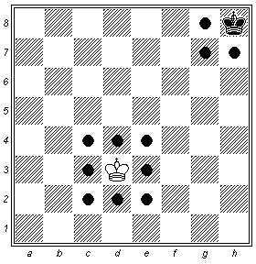

CHESS ETIQUETTE  - Practice good sportsmanship  - Introduce yourself  - Shake hands at the start of the game  - Be respectful of your opponent  - Do not make noise or distract them  - Do not taunt or intimidate your opponent  - Shake hands at the end of the game  - Be a graceful winner or dignified loser  POINT VALUES & SYMBOLS OF PIECES | CHECK / CHECKMATE / STALEMATE  The King is in CHECK when in danger, and must get out of danger right away.  In order to do this, you can:  C – Capture the checking piece  P – Protect your King by blocking check  R – Run away, move to a safe square  Another way to remember this is:  A – Avoid check, run away to a safe square  B – Block check with another piece  C – Capture the piece that has you in check  When your King is in CHECK and you cannot do any of these, that is called CHECKMATE and is the end of the game!  A STALEMATE occurs when your King is NOT in CHECK and has no safe square to move to, AND you have no other piece(s) that can move. | CASTLING  - King moves two squares to either side  - Rook moves to the other side of the King  - You can Castle King-side OR Queen-side  - Beginners are encouraged to Castle their King to safety early  - Be mindful of the timing when you Castle; be careful not to lose position, or sacrifice the development of other pieces  - Another benefit to Castling is moving a Rook out of the corner and into the game  - To convey your intent to Castle, it helps to move the King first, then the Rook  Castling CANNOT be done if:  - King or Rook has already been moved  - All the spaces between the King and Rook are not empty  - King is in check  - King would move into check  - King would travel through check | OPENING PRINCIPLES  - Control the Center – At the start of each game, place your Pawns in the center, and focus your attention here  - Develop your pieces quickly – Get your Knights and Bishops out as soon as you can, within the first six or seven moves.  - Castle early on in the game – Protect your King and, when you move the Queen up, connect your Rooks.  - Keep your pieces protected – Don’t leave your pieces hanging without protection. Protecting means if your opponent can take your piece, then you can take your opponent’s piece.  Things to Think About Each Turn  - Can I capture a piece for free, meaning I won’t lose the piece I use to capture?  - Do I have unprotected pieces, ones my opponent can capture for free?  - Am I a turn or two away from being checkmated, and what can I do about it?

